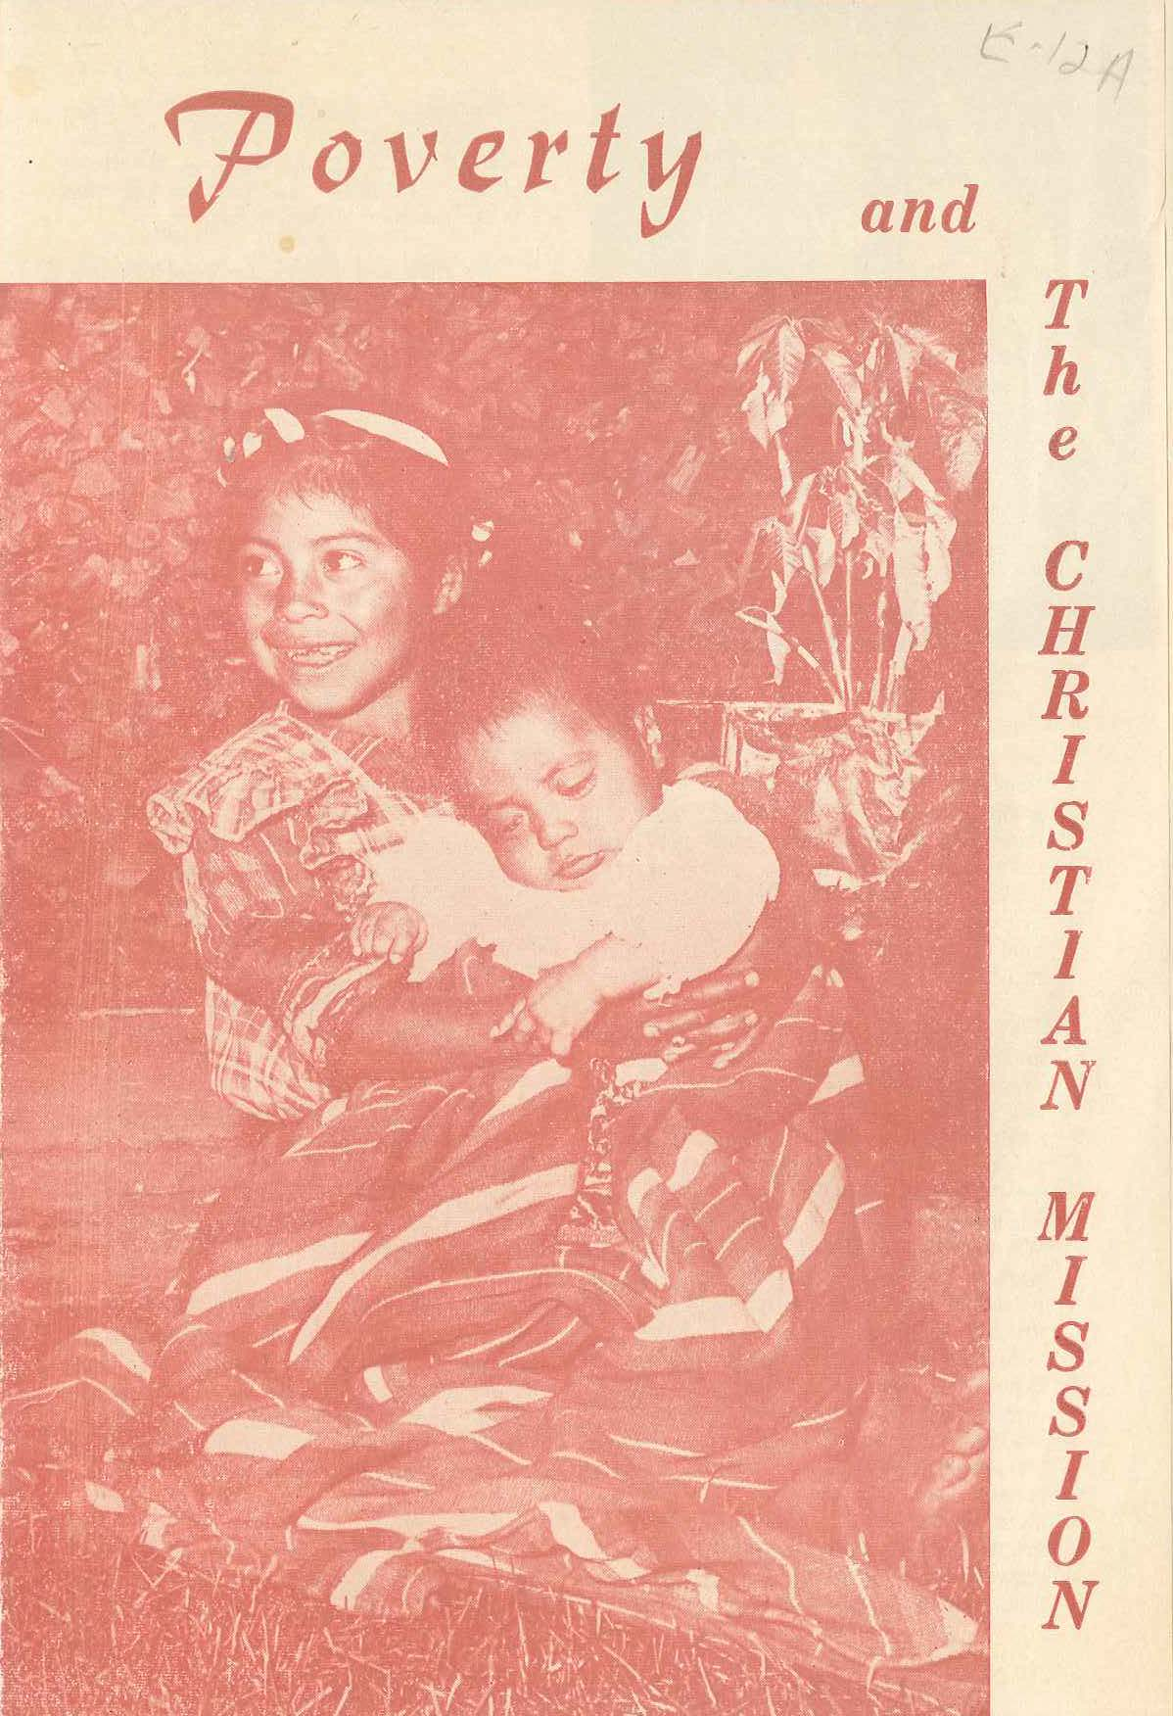
[This is listed on the file as an “older” writing. It is likely that the “E-File” was started by Winter while at Fuller in around 1970. This document was printed up and circulated as a small 8 x 6 brochure. Winter had written in one copy changes, which have been included in this version E 12a.1. Subject: Poverty, social gospel, transformation.]

Poverty and the Christian Mission
Ralph D. Winter

One’s first reaction on arriving among people desperately poor is to do something. You see Indians picking up individual grains of corn from the gutters. They sell their few eggs because they get more calories in the monetary equivalent of a grain. At 5 am. Little 5-year-old children are out on the roads stumbling along behind their parents, carrying astonishingly heavy loads.

They walk 20 miles to be able to plant another few square feet of corn. Desperate arguments arise over inches of land. Christian families, swollen by the presence of medical help and the absence of money for birth control materials, present children that are inevitable vagrants and who cannot marry for lack of land inheritance. When Pedro, a Presbyterian elder’s son, wanted to marry Tons, the daughter of a leading deacon, her father said no. Pedro has 19 living brothers and sisters.

In Guatemala and in Latin America in general, things are not so well ordered and understood as they are in the U. S. where a pastor rarely needs to worry about his people finding jobs. Only the refugee family comes up for such consideration. Even there, many community resources are already available. Automation, railway firemen, and blind type are phrases that remind us that all our problems of transition are not behind us. But here in Guatemala a perfectly vast scramble and shuffle is taking place as the result of the “catching on and catching up” that is the disorder of the decade.

We North Americans come here like men from Mars, so to speak; from a culture that is a few stages in growth beyond the largely agrarian, self-subsistent economy that still characterizes 80% of the Guatemalans (most of whom are patient Indians working away in ways that are completely outmoded). If simple hard work could solve their problems there would be no problem. But the road ahead is not straight. It has vicious curves they may go off. They’ve never had enough money so far to find out what liquor can do for them. Their sacrificial efforts in learning a new trade—like say tailoring—may tomorrow be undercut by the arrival of low-priced machine-made garments from the Capital.

The sensitive Christian conscience is hurt by these things. Furthermore it is not merely that the Indians are poor, especially so the Christians in many cases, but because it is in the nature of the Christian faith to “lift the heavy burdens” (Isa. 58:6) and to share medical progress and modern wonders. Science, as the wonderland of God’s handiwork, belongs as much to God’s Indian as the God’s Californian.

But to obtain outside food donations doesn’t really solve the problem. Nor money for food. In our valley of 20,000 Indians a million dollars given outright would supply food for only a few months—and then what?

Nor can these Indians grow a whole lot more corn in the land they have; and population growth can easily outstrip that. Land enough there is, on the uninhabitable and disease-ridden tropical coast. Here in the cool, beautiful highlands is where most of the people live.

Nor can the missionary readily enter into high-level economic planning. The government offices are buzzing with studies and plans, and with hundreds of U. S. advisors. And with all that help, Government efforts themselves are often shortsighted. Relocating people on the coastal land is merely postponing the evil day when there will come in flood tide the inevitable shift from hand-agriculture-of-the masses to mechanized agriculture of a few—and the secondary result of large-scale technological unemployment. (Who shou1d know this better than those in the U. S.?)

But in any case it is a fact that even if Christians didn’t need food, church buildings and pastors’ salaries take money; and a Christian community that is getting the rug pulled out from under it is in no great shape to pour funds into outreach.

On the personal level we can advise young men that there is no future in custom-made clothes (all clothes in rural areas still tend to be made by hand in little one-sewing-machine shops). This is negatively good; can we be positively helpful and bring training in skills-with-a future? Do we really need to bother about these problems at all?

As a rule the more recently arrived missions in Guatemala (e. g. Pentecostal, Southern Baptist, Mormon) are all strictly gospel preaching and no nonsense about economic problems. They obviously haven’t yet faced the physical conditions of their future constituencies. But the older missions that have raised up thousands of believers over more than half a century are faced with the problems of success: do we help the already-Christians in all their problems of development and outreach, individual and church finance? Do we help them to relate to the world as it is today? Or do we let Radio Cuba be the only voice discussing their practical problems?

It may be that the New England Puritan can give us a lead here. They faced desperate economic problems, and their preachers came equipped with a theology that made every task a holy calling. To Rev. John Cotton, “a Christian would no sooner have his sin pardoned than his life established in some good calling.” To them getting productively established in (this) God’s world was vitally import as a Spiritual task! Vocational rehabilitation—as secular as that phrase now sounds—was part of their theology of redemption.

Every missionary worth his salt, no matter what his board, bases his work 100% on the assumption that there is nothing really possible in human development except it be built on a transformed inner spirit. Even secular experts, Peace Corps people, or whoever it is at work with human clay, must sense at last that when the inner spirit of man is damaged, dampened, or degraded, there is precious little hope for economic schemes and programs. The Biblical promise “I will put a new Spirit within you” (Ezekiel 11:19) is the only one you can build on.

This is why ministers and take heart. Their work is bedrock. No industrial process is more miraculous than the transformation of the heart and life of man. This phenomenon is taking place daily-and progressively in the lives of those who have already surrendered all to Christ. The secular mind looks the other way, belittles and ignores this kind of work. It is too intangible, unscientific. Yet it is the glory of the U. S. protestant Christian mission agencies that as the result of their work there are now in the countries of the non-western world something like 60,000,000 (sixty million) followers of Christ (and immeasurable indirect influences), who constitute in their countries the highest quality sub-community. And this is not an intangible result. They are the alert, bright-eyed, honest people who set the standards for morality and hope. This is an immense but “invisible” movement you can never read about in the papers. It is not the sudden or tragic thing papers feed on.

Yet, believe it or not, there it was in the paper a few days ago—in the leading Guatemalan daily - in letters one half inch high, “Young Protestant wanted”, an ad offering a fabulous salary at least four times as high as the average pastor here gets. The North American company running this huge want-ad apparently believes you can build on a transformed life.

It is well and good that we fear the sentimental idealism involved in “social gospel” efforts to build economic progress on untransformed people asking no questions about the sickness of the inner man. But it is probably a mistake to transfer this fear to the case of those who are genuinely transformed. This kind of fear perpetuates itself by stowing away in the memory many examples of how “even Christians in these countries can’t be trusted with money,” etc. It doesn’t quite jive, of course, with our confident reports of how many have been soundly converted!

It is true that a converted Indian doesn’t necessarily immediately know how to handle money like he has learned over the centuries to save and manage corn. But with such a man you at least have something sound to build on. Shall we teach him everything except how to handle money?

One answer may be to work through a somewhat new kind of pastor, teach him the broad outlines of what the modem world consists of, and among other things how his people will have to adjust radically to meet changing circumstances, and that his people desperately need, along with bedrock faith and love, the elements of broad orientation and technical training that will prepare them in creativity, resourcefulness, and durability-with-flexibility to land on their feet like a cat in the rough and tumble ahead. Perhaps these new pastors can both learn and teach up-to-date trades and businesses. The most sturdy and reliable elements in the population are the available raw materials. In the poorest Indian areas both the culture and the economics of the situation may demand that the pastor be self-supporting in part, as were Presbyterian ministers to a great extent up until a few years ago in the States. Best of all, occupied in some portable job like weaving, as was the Apostle Paul—and for the same reasons.

It’s interesting to speculate what kind of book the New Testament would have been had no one ever taught Paul a trade. Then too, the communistic air Latin America is breathing these days as much as states that the pastor who does no concrete work is a social parasite. Paul worked with his hands in part possibly to set an example for his people to follow: “with toil and labor we worked night and day... to give you an example to imitate” (2 Thess 3:8,9). Is this out of date or up to date? What is up to date?

You who are reading this article may well have some keen ideas. Could you afford 13 cents (3 sheets) and a few moments to share them with us? Must of us working with the Guatemalan Presbyterian Church are related to this problem of what kind of direction and leadership is most needed. Some of us spend our whole time wrestling with it. We don’t claim to know all the answers. Our hearts have not lost their ache. Send your ideas. Better still, come and see and study and work and pray with us!

Dr. RALPH D. WINTER
MAM Christian Center
San Juan Ostuncalco, Quez. Guatemala. C.A

Note: Winter originally had the phrase here, “Johnny come lately”. He also said in a later sentence they “had not stopped to think about” the physical conditions….

